**GLASSCOCK GROUNDWATER CONSERVATION DISTRICT**

**GROUNDWATER**

**MANAGEMENT PLAN ~~2024-2029~~**

Adopted : INSERT DATE HERE

**P.O. Box 208**

**132 N. Main**

**Garden City, Texas 79739**

**Ph: 432-354-2430 Fax: 432-354-2322 E-mail: glasscockgroundwater@yahoo.com**

**Website: glasscock-groundwater.org**

Table of Contents

District Mission1

Time Period for this Plan1

Statement of Guiding Principles1

General Description1

Regional Cooperation and Coordination2

Location and Extent3

Topography and Drainage3

Groundwater Resources4

Edwards-Trinity (Plateau) Aquifer4

Ogallala Aquifer5

Dockum Aquifer6

Lipan Aquifer7

Technical District Information Required by Texas Administrative Code7

Modeled Available Groundwater in the District8

Amount of Groundwater Being Used within the District on an Annual Basis8

Annual Volume of Water that Discharges from the Aquifer to Springs and Surface Water Bodies8

Estimate of the Annual Volume of Flow into the District, out of the District and Between Aquifers in the District8

Projected Surface Water Supplies within the District8

Projected Total Demand for Water within the District9

Water Supply Needs9

Water Management Strategies9

Management of Groundwater Supplies, and Actions, Procedures, Performance and Avoidance Necessary to Effectuate the Management Plan9

Goals, Management Objectives, and Performance Standards10

Goal 1.0 – Controlling & Preventing Waste of Groundwater - §36.1071(a)(1) 10

Goal 2.0 - Providing the Efficient Use of Groundwater - §36.1071(a)(1) 11

Goal 3.0 – Addressing Drought Conditions- §36.1071(a)(6) 11

Goal 4.0 – Addressing Conservation, Rainwater Harvesting, and Brush Control where appropriate and cost effective - §36.1071(a)(7) 12

Goal 5.0 – Addressing the Desired Future Conditions established under 31.108 - §36.1071(a)(8) 12

Goal 6.0 – Addressing Natural Resources Issues - §36.1071(a)(5) 13

Management Goals Determined Not-Applicable14

Goal 7.0 – Addressing Precipitation Enhancement - §36.1071(a)(7) 14

Goal 8.0 – Addressing Recharge Enhancement - §36.1071(a)(7) 14

Goal 9.0 – Controlling and Preventing Subsidence - §36.1071(a)(7) 14

Goal 10.0 – Addressing Conjunctive Surface Water Management Issues - §36.1071(a)(4) 14

Appendix A – Administrative Documents; Adoption Meeting Notice, Meeting Agenda and ResolutionXX

Appendix B – ~~Estimated Historical Groundwater Use and 2017 State Water Plan Datasets: Glasscock Groundwater Conservation District~~XX

Appendix C – ~~GAM Run X-XXX: Glasscock Groundwater Conservation District Management Plan~~XX

District Mission

The Glasscock Groundwater Conservation District strives to bring knowledge about conservation, preservation, and the efficient, beneficial, and wise use of water for the benefit of the citizens and economy of the District through monitoring and protecting the quality of the groundwater.

The District seeks to protect the groundwater quality and quantity within the District, pursuant to the powers and duties granted under Chapter 36, Subchapter D of the Texas Water Code. Any action taken by the District shall only be after full consideration and respect has been afforded to the individual property rights of all citizens of the District. The District also seeks to maintain groundwater ownership and rights of the landowners and their lessees as provided in the Texas Water Code §36.002.

Time Period For This Plan

This plan becomes effective upon adoption by the District Board of Directors and approval by the Texas Water Development Board (TWDB) affirming the plan is administratively complete. This plan remains in effect for five years or until amendment or adoption of a new plan.

Statement Of Guiding Principles

The primary concern of the residents of this area of the State regarding groundwater is the potential contamination of the groundwater from the vast amount of oil and gas production and the activities involved in the production of oil and gas. For this reason, the residents asked Representative Tom Craddick to introduce legislation to create this groundwater conservation district. The District recognizes that the groundwater resources of this region are of vital importance to the residents and that this resource must be managed and protected from contamination. The greatest threat to prevent the District from achieving the stated mission is from state mandates and agency bureaucrats who have no understanding of local conditions. A basic understanding of the aquifers and their hydrogeologic properties, as well as a quantification of resources is the foundation from which to build prudent planning

measures. This management plan is intended as a tool to focus the thoughts and actions of those given the responsibility for the execution of District activities.

General Description

The Glasscock Groundwater Conservation District (GCD) was created by Acts of the 67th Legislature (1981). In August 1981, the residents confirmed the District and voted to fund the district operations through local property taxes. It became an active District in August 1981. On April 15, 1986, the District adopted Rules and By-Laws which became effective immediately and on February 21, 1989 the District adopted a management plan. With the adoption of these rules, the District implemented a well permitting and registration program. The District rules were amended on December 20, 2022. The current members of the Board of Directors are: Galen Schwartz; President, Allan Fuchs; Vice President, Bart Belew; Member, Russell Halfmann; Member and Lane Halfmann; Member. The District General Manager is Rhetta Hector and Rocio De Luna is the Administrative Assistant. The Glasscock GCD covers all of Glasscock County and a portion of Northwest Reagan County. The District’s economy is based primarily on agriculture, and oil and gas production. The agricultural income is derived primarily from cotton, grain sorghum, wheat, alfalfa, pecans, as well as sheep, goats, and beef cattle production. Recreational hunting leases also contribute to the income of the area.

Regional Cooperation & Coordination

**West Texas Regional Groundwater Alliance**

Since 1988 the District has been involved in coordination of district activities with other GCD’s managing the Edwards-Trinity (Plateau) Aquifer. In 1988, four groundwater conservation districts; Coke County UWCD, Glasscock County UWCD, Irion County WCD, and Sterling 3 County UWCD signed an original Cooperative Agreement. As new districts were created, they too signed the Cooperative Agreement. In the fall of 1996, the original Cooperative Agreement was redrafted, and the West Texas Regional Groundwater Alliance was created. Today, the regional alliance consists of eighteen locally created and locally funded groundwater conservation districts covering all or part of twenty-six counties, that encompass approximately 18.2 million acres or 28,368 square miles of West Central Texas. This West Texas region is as diverse as the State of Texas. Due to the diversity of this region, each member district provides its own unique programs to best serve its constituents. Current member districts are:

Coke Co. UWCD Crockett Co. GCD Glasscock GCD

Hickory UWCD # 1 Hill Country UWCD Irion Co. WCD

Kimble Co. GCD Lipan-Kickapoo WCD Lone Wolf GCD

Menard Co. UWD Middle Pecos GCD Permian Basin UWCD

Plateau UWC & SD Reeves Co. GCD Santa Rita UWCD

Sterling Co. UWCD Sutton Co. UWCD Wes-Tex GCD

This regional alliance was created because the local districts have a common objective:

1. to facilitate the conservation, preservation and protection of groundwater supplies,
2. protection and enhancement of recharge,
3. prevention of waste and pollution, and
4. beneficial use of water and related resources.

Local districts monitor water-related activities which include but are not limited to the State’s largest industries of farming, ranching and oil and gas production. The regional alliance provides coordination essential to the activities of these member districts as they monitor these activities in order to accomplish their objectives.

**Regional Water Planning**

The District has been active in the Region F, Regional Water Planning Group meetings to provide input in developing and adopting the 2001, 2006, 2011, 2016, and 2021 regional plans. As the regional planning group moves toward adopting future Regional Plans the District will continue to participate in the planning process.

**Groundwater Management Area**

Groundwater Management Area 7 covers all or part of thirty-three counties and includes twenty groundwater conservation districts. These GCD’s manage groundwater resources at the local level in all or part of twenty-four counties within GMA 7 and surrounding areas. The District continues to actively participate in meetings and discussions to determine a feasible future desired condition of the aquifers within the management area and district.

Location And Extent

The Glasscock GCD has an aerial extent of approximately 900 square miles or approximately 571,499 acres of land in Glasscock County and 65,350 acres in Northwest Reagan County. The total population of the District is approximately 1,400 people. There are no incorporated cities within the District boundaries. The two communities within the District are Garden City and St. Lawrence. Land use in the District is for agricultural purposes of which 151,000 acres is crop or farmland, 85,009 acres is improved pasture, and the balance of 400,840 acres is rangeland. The majority of the District is over the Edwards-Trinity (Plateau) Aquifer with exception of the northwest part of Glasscock County which is over the Ogallala Aquifer. The cropland is located primarily in the southern and northwest portions of the District, with the balance being in pasture and rangeland. Irrigation covers approximately 36,529 acres of the District’s cropland. Of these acres, 26,529 are located in Glasscock County and 10,000 acres are located in Reagan County. Historically, the principal method of irrigation had been furrow irrigation. However, within recent years there has been a gradual trend to change to more highly efficient subsurface drip irrigation and low energy precision application (LEPA) center pivots. There are currently, approximately 28,400 acres of subsurface drip irrigation and 5,129 acres of LEPA center pivots within the District. The remaining 3,000 acres is furrow irrigation.

The District is included in the Ccolorado River Basin, Region F Regional Water Planning Group and Groundwater Management Area 7.

Topography And Drainage

The District is within what is known as the Permian Basin of Texas. Topographically, the area within the District is generally nearly level to undulating plain that slopes upward from the east to the west. The altitude of the land surface ranges from 2,300 feet above sea level in the eastern part of the District to about 2,750 feet above sea level in the western part of the District.

The Glasscock GCD lies within the Colorado River Basin. The North Concho River is a tributary of the Colorado River and is located in the northeast part of the District.

Groundwater Resources

**Edwards-Trinity (Plateau)**

The Edwards-Trinity (Plateau) Aquifer underlies the entire District except in the northwest portion of Glasscock County. Water from this aquifer is principally used for irrigation, rural, domestic, and livestock needs. This aquifer consists of saturated sediments of lower Cretaceous Epoch Trinity Group formations and overlying limestones and dolomite of the Comanche Peak, Edwards, and Georgetown formations. The Glen Rose Limestone is the primary unit of the Trinity Group in the southern part of the plateau and is replaced by the Antlers Sand north of the Glen Rose pinch out. Reported well yields range from 20 gal/min, where saturated thickness is thin, to more than 300 gal/min, within the District. Chemical quality of Edwards-Trinity (Plateau) water ranges from fresh to slightly saline. The water is typically hard and may vary widely in concentrations of dissolved solids made up mostly of calcium and bicarbonate. The salinity of the groundwater tends to increase toward the west. Certain areas have unacceptable levels of fluoride. Water levels have declined as a result of increased pumpage and the increase of harmful vegetation such as mesquite and prickly pear. The average decline has been approximately 20 feet since 1980. (See map below)

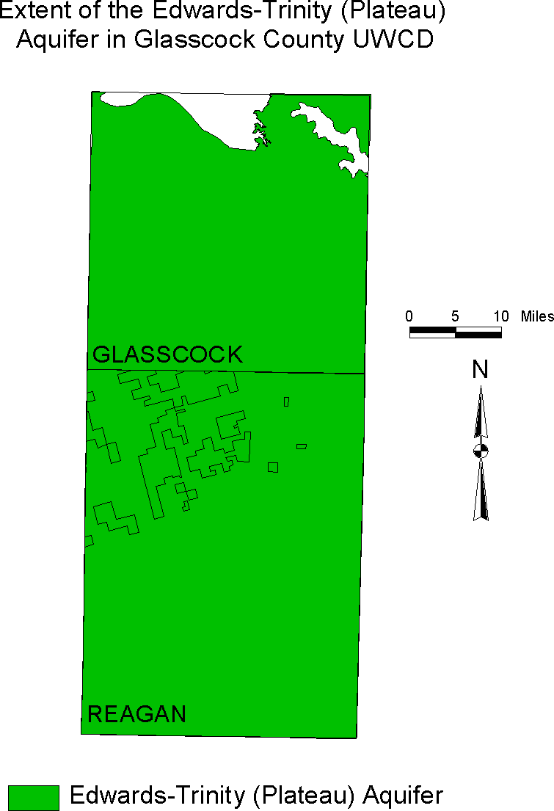

**Ogallala Aquifer**

The Ogallala Aquifer is located in northwest Glasscock County. It is composed primarily of sand, gravel, clay and silts deposited during the Tertiary Period. Water from this aquifer is principally used for irrigation, rural domestic, and livestock needs. Water yields from this aquifer are generally greater than 150 gal/min. The chemical quality of the water in the aquifer is generally fresh; however, higher levels of dissolved-solids and chloride concentrations can be found within the District. Water levels have fluctuated in this area due to several acres participating in the USDA Conservation Reserve Program being removed and put back into production. (See map below)

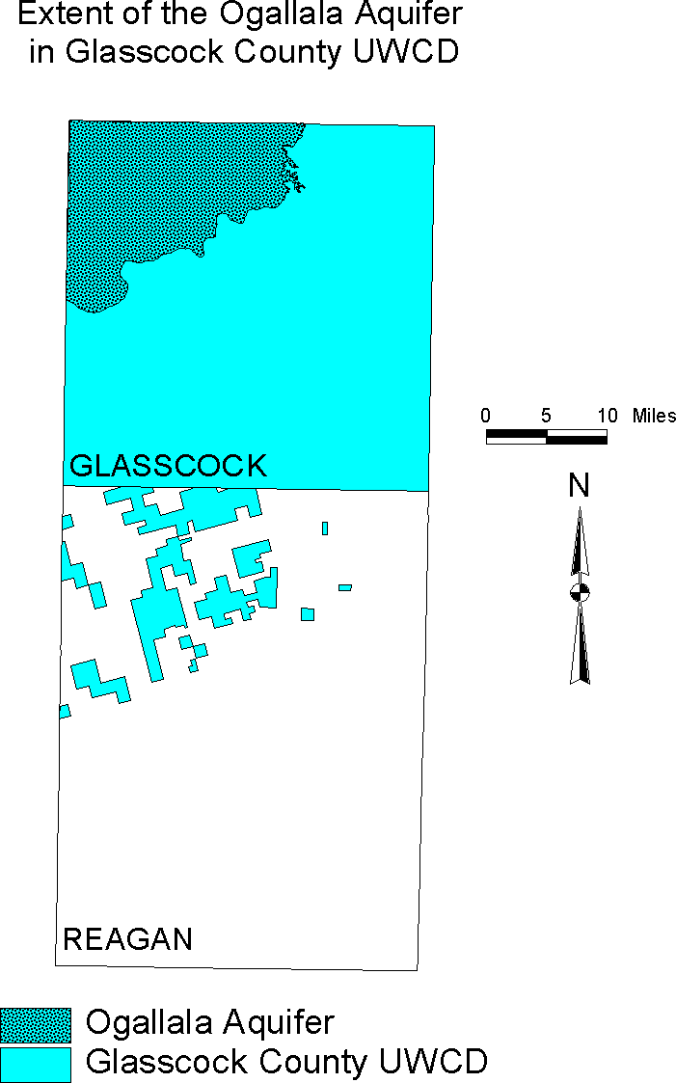

**Dockum Aquifer**

The Dockum Aquifer is a minor aquifer found in the northwest part of the state. It includes the Santa Rosa Formation, the Tecovas Formation, the Trujillo Sandstone, and the Cooper Canyon Formation. The water quality in the aquifer is generally poor—with freshwater in outcrop areas in the east and brine in the western subsurface portions of the aquifer—and the water is very hard. Naturally occurring radioactivity from uranium present within the aquifer has resulted in gross alpha radiation in excess of the state’s primary drinking water standard. Radium-226 and -228 also occur in amounts above acceptable standards. Groundwater from the aquifer is used for irrigation, municipal water supply, and oil field waterflooding operations.

The Dockum aquifer is located in the extreme eastern portion of the District. This aquifer is used principally for livestock needs. (See map below)

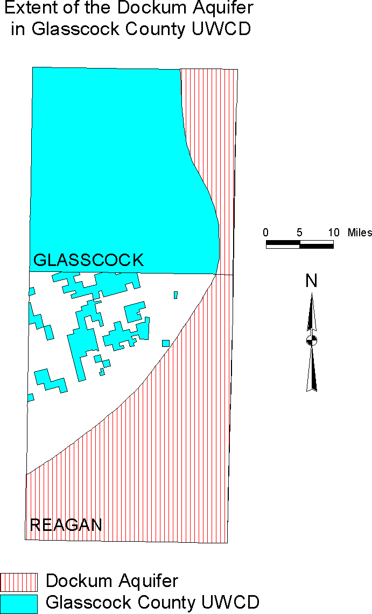

**Lipan Aquifer**

The Lipan Aquifer is a minor aquifer found in parts of Coke, Concho, Glasscock, Irion, Runnels, Schleicher, Sterling, and Tom Green counties in west-central Texas. Groundwater in the alluvium ranges from fresh to slightly saline, containing between 350 and 3,000 milligrams per liter of total dissolved solids, and is very hard. The aquifer is primarily used for irrigation but also supports livestock and municipal, domestic, and manufacturing uses. Because of drought and heavy irrigation pumping in the late 1990s, water levels decreased significantly in some areas, and the aquifer could not be pumped through the entire irrigation season. In other areas, however, the aquifer could be pumped, but only at a reduced rate.

The aquifer explanations above were taken from the Texas Water Development Board’s Report 380, Aquifers of Texas.

Technical District Information Required By Texas Administrative Code

Texas Water Code § 36.001 defines modeled available groundwater as “the amount of water that the executive administrator determines may be produced on an average annual basis to achieve a desired future condition established under Section 36.108.”

The joint planning process set forth in Texas Water Code § 36.108 must be collectively conducted by all groundwater conservation districts within the same GMA. The District is a member of GMA 7. GMA 7 declared the Dockum and Lipan Aquifers as not relevant for regional planning purposes in the Sterling County Underground Water Conservation District and adopted DFCs for the Edwards/Trinity (Plateau) Aquifer on August 19, 2021. The adopted DFCs were forwarded to the TWDB for development of the MAG calculations. The submittal package for the DFCs can be found here: <https://www.twdb.texas.gov/groundwater/management_areas/gma7.asp>

A summary of the desired future conditions and the modeled available groundwater are summarized below.

Ogallala Aquifer: An average drawdown of 6 feet for the Ogallala Aquifer based on the GMA 7 Technical Memorandum 18-01.

Edwards/Trinity (Plateau) Aquifer: An average drawdown of 42 feet for the Edwards-Trinity (Plateau) aquifer based on the GMA 7 Technical Memorandum 18-01.

Dockum Aquifer: Not relevant for joint planning purposes within the boundaries of Glasscock Groundwater Conservation District

Lipan Aquifer: Not relevant for joint planning purposes within the boundaries of Glasscock Groundwater Conservation District.

Estimated Modeled Available Groundwater in ac/ft for the Ogallala Aquifer by district from GAM RUN 21-012 MAG.



Estimated Modeled Available Groundwater in ac/ft for the Edwards/Trinity (Plateau) Aquifer by district from GAM RUN 21-012 MAG.



**Modeled Available Groundwater in the District**

Please refer to Appendix A

**Amount of Groundwater being Used within the District on an Annual Basis**

Please refer to Appendix B

**Annual Amount of Recharge from Precipitation to the Groundwater Resources within the District on an Annual Basin**

Please refer to GAM Run 24-010 in Appendix C

**Annual Volume of Water that Discharges from the Aquifer to Springs and Surface Water Bodies** Please Refer to GAM Run 24-010 in Appendix C

**Estimate of the Annual Volume of Flow into the District, out of the District and Between Aquifers in the District**

Please refer to GAM Run 24-010 in Appendix C

**Projected Surface Water Supplies within the District**

No surface water management entities exist within the District. There are no surface water impoundments within the District except for livestock consumption. There are no surface water entities located within the District to coordinate the development of this plan.

Please refer to Appendix B.

**Projected Total Demand for Water within the District**

Projected water demands do not exceed projected available groundwater in Glasscock County.

Please refer to Appendix B

**Water Supply Needs**

There are no water supply needs listed in the state water plan section of the TWDB Estimated Historical Water Use/2022 State water plan data report.

The residents of the District understand that groundwater supplies are limited and have modified farming and ranching techniques to match the availability of water. There are currently, approximately 28,400 acres of subsurface drip irrigation and 5,129 acres of LEPA center pivots within the District, with more acres going in every year. Efforts are being made by the residents of the District to use the available groundwater resources with maximum efficiency, while monitoring the quality of the groundwater to protect this resource for the years to come. The District has considered the water supply needs in Glasscock County and given the District’s jurisdictional boundaries and the remote location; the District considers this to be not relevant.

Please refer to Appendix B

**Water Management Strategies**

The District continues to encourage conservation and reuse to meet the projected strategies in the 2021 Region F Water Plan. The water management plan strategies for the District include irrigation conservation, municipal conservation, mining conservation, and brush control.

Please refer to Appendix B.

Management Of Groundwater Supplies, And Actions, Procedures, Performance, And Avoidance Necessary To Effectuate The Management Plan

Since 1981, the District has and will continue to manage the supply of groundwater within the District, in order to conserve the resource while seeking to maintain the economic viability of all resource user groups, public and private. In consideration of the economic and cultural activities occurring within the District, the District will continue to identify and engage in such activities and practices, that if implemented, would result in preservation and protection of the groundwater. The observation network will continue to be reviewed and maintained in order to monitor changing conditions of groundwater within the District. The District will undertake investigations of the groundwater resources within the District and will make the results of investigations available to the public.

The District has, or will amend as necessary, rules to regulate groundwater withdrawals by means of spacing and/or production limits. The relevant factors to be considered in making the determination to grant a permit or limit groundwater withdrawal will include:

* + 1. The purpose of the District and its rules;
    2. The equitable conservation and preservation of the resource; and
    3. The economic hardship resulting from granting or denying a permit or the terms prescribed by the rules.

In pursuit of the District’s mission of preserving and protecting the resource, the District will enforce the terms and conditions of permits and the rules of the District by enjoining the permit holder in a court of competent jurisdiction, as provided for in TWC Chapter 36.102, if necessary.

The District shall treat all citizens with equality. Citizens may apply to the District for discretion in enforcement of the rules on grounds of adverse economic effect or unique local characteristics. In granting of discretion to any rule, the Board shall consider the potential for adverse effect on adjacent owners and aquifer conditions. The exercise of said discretion by the Board shall not be construed as limiting the power of the Board.

Current District rules are available at <https://www.glasscock-groundwater.org/rules-by-laws>.

**Methodology for Tracking Progress**

The methodology that the District will use to trace its progress on an annual basis in achieving all of its management goals will be as follows:

* + 1. The District holds a regular board meeting for the purpose of conducting District business,
    2. Each month the District General Manager will present permit applications/registration forms to the Board for approval,
    3. inform the Board of drought severity within the District and,
    4. wasteful practices observed by District staff or reported to staff,

Additionally, the District General Manager will prepare and present an annual report to the Board of Directors on District performance in regard to achieving management goals and objectives for the preceding fiscal year. The report will include the number of instances each activity was engaged in during the year. The annual report will be maintained on file at the District office.

GOALS, MANAGEMENT OBJECTIVES And PERFORMANCE STANDARDS

**Goal 1.0 - Controlling and Preventing Waste of Groundwater §36.1071(a)(1)**

The District strives to minimize potential waste and contamination of groundwater by monitoring wasteful practices either observed by District staff or reported to District staff.

Management Objective

1.1 Each month, the District will investigate all identified wasteful practices within two (2) working days of identification or complaint received.

Performance Standard

1.1a The District General Manager will report the number of wasteful practices identified and the average number of days District personnel took to respond or investigate after identification or complaint received.

1.1b District staff will provide the Board with findings, reports, and updates at monthly board meetings.

**Goal 2.0 Providing the Most Efficient Use of Groundwater §36.1071(a)(1)**

The District strives to gather groundwater data to improve the understanding of the aquifers and their hydrogeologic properties and to quantify this resource for prudent planning and efficient use.

Management Objective

2.1 Each year, the District will provide laser plane leveling equipment (based upon availability) to producers for better irrigation planning and contour farming free of charge.

Performance Standard

2.1a The District General Manager will present an Annual Report to the Board of Directors the number of times District’s leveling equipment was loaned to producers.

**Goal 3.0 Addressing Drought Conditions §36.1071(a)(6)**

The District’s lack of surface water supplies and semi-arid climate conditions results in drought monitoring being an important component of informed management. The District strives to remain aware of ever-changing climatic conditions.

Management Objective

3.1 The District will monitor the Palmer Drought Severity Index (PDSI) by Texas Climatic Divisions. <https://www.waterdatafortexas.org/drought>

Performance Standard

3.1a The District staff will report the PDSI findings and actions to the Board of Directors at least quarterly.

Management Objective

3.2 Management Objective the District will maintain a rainfall monitor network.

Performance Standard

3.2a The District staff will report the rainfall monitoring network data to the Board of Directors at least quarterly.

**Goal 4.0 Addressing Conservation, Rainwater Harvesting, and Brush Control where appropriate and cost effective. §36.1071(a)(7)**

The District strives to promote water management strategies recommended in the 2021 Region F Regional Water Plan that have the potential to promote local groundwater supplies and maintain financial responsibility.

Management Objective: Conservation

4.1 The District will continue to be a source for informational materials, literature and programs to improve public awareness of efficient use, wasteful practices and conservation measures.

Performance Standard: Conservation

4.1a The District staff will provide information to area residents at least once a year.

<http://www.savetexaswater.org>

4.1b The District General Manager will present an Annual Report to the Board of Directors the number of times the District provided information to area residents.

Management Objective: Rainwater Harvesting

4.2 District staff will provide information to area residents at least once a year.

Performance Standards: Rainwater Harvesting

4.3a The District General Manager will present an Annual Report to the Board of Directors the number of times the District provided information to area residents.

Management Objective: Brush Control

4.3 District staff will provide information to area residents at least once a year.

Performance Standards: Brush Control

4.4a The District General Manager will present an Annual Report to the Board of Directors the number of times the District provided information to area residents.

**Goal 5.0 Addressing the Desired Future Conditions established under §36.108**

**§36.1071(a)(8)**

The District strives to gather data to improve the understanding of the aquifers and their hydrogeologic properties and in the establishment and monitoring of achievement of desired future conditions.

Management Objective

5.1 The District has established an Observation Well Program to monitor water levels and evaluate whether the average change in water well levels is in conformance with the Desired Future Conditions adopted by the District. The District will estimate total annual groundwater production for each aquifer based on water use reports, estimated exempt use and other relevant information, and compare these production estimates to the MAGs. Each year, the District will measure, record, and accumulate a historic record of water levels in the Observation Well Program.

The DFCs for GMA 7 can be seen here:

[2021 Joint Groundwater Planning | Texas Water Development Board](https://www.twdb.texas.gov/groundwater/dfc/2021jointplanning.asp" \o "TWDB - 2021 Joint Groundwater Planning)

Performance Standards

5.1a The District will maintain files and records including the number of water levels measured and static level information on the District Observation Well Program.

The District will record the water level data and average annual change in water levels for each aquifer and compare them to the DFCs.

5.1b Record the total estimated annual productions for each aquifer and compare these amounts to the MAG. The District General Manager will present an Annual Report to the Board of Directors with the Observation Well Program measurements.

**Goal 6.0 Addressing Natural Resource Issues §36.1071(a)(5)**

The District strives recognizes the reliance of other natural resources on groundwater supplies.

Management Objective

6.1 District staff will submit all requested water quality samples within 7 business days from receipt.

Performance Standards

6.1a The District General Manager will present an Annual Report to the Board of Directors the number of results that were submitted to the laboratory for water quality testing in the District’s annual report.

Management Objective

6.2 This District will inspect any abandoned wells discovered by District staff or reported to the District and send a letter to the landowner requiring the well be covered or plugged in accordance with state laws.

Performance Standards

6.2a The District General Manager will present an Annual Report to the Board of Directors the number of abandoned well enforcement letters mailed out in the District’s annual report.

Management Objective

6.3 The District will require all wells drilled for oil and gas operations be permitted or registered, including meeting the spacing standards if applicable.

Performance Standards

6.3a The District General Manager will present an Annual Report to the Board of Directors the number wells drilled for this purpose in the District’s annual report.

**MANAGEMENT GOALS DETERMINED NOT APPLICABLE**

**Goal 7.0 Addressing Precipitation Enhancement §36.1071(a)(7)**

The Board of Directors has determined precipitation enhancement not to be cost-effective for the District. Therefore, this goal is not applicable to the operations of the District.

**Goal 8.0 Addressing Recharge Enhancement §36.1071(a)(7)**

The diverse topography, and limited knowledge of any specific recharge sites makes any type of recharge enhancement project economically unfeasible. According to the TWDB Statewide Survey of ASR and AR Suitability, the Glasscock Groundwater Conservation District has a suitability rating that ranges from *no need identified, less suitable or moderately suitable*( https://arcg.is/0zPHir0 ). This management goal is not applicable to the operation of the District.

**Goal 9.0 Controlling and Preventing Subsidence §36.1071(a)(7)**

The rigid geologic framework of the region precludes significant subsidence from occurring, as identified in the *Identification of the Vulnerability of the Major and Minor Aquifers of Texas to Subsidence with Regard to Groundwater Pumping – TWDB Contract Number 1648302062 report by LRE Water* (<https://www.twdb.texas.gov/groundwater/models/research/subsidence/subsidence.asp>). In Table 1.4 (page 28 of 434) the Edwards- Trinity aquifer is considered low risk as a whole. Tables 4.7 and 4.18 (page 80 & 81 of 434) identifies the risk for well locations in Glasscock & Reagan Counties to be a low subsidence risk for the aquifer as a whole. As a result, this goal is not applicable to the operations of the District.

**Goal 10.0 Addressing Conjunctive Surface Water Management Issues §36.1071(a)(4)**

No surface water management entities exist within the District. There are no surface water impoundments within the District except for livestock consumption. The Glasscock GCD has no jurisdiction over surface water. The groundwater within the district is used primarily for irrigated agriculture, rural domestic, livestock and petroleum drilling and exploration needs. This goal is not applicable to the operations of the District.

# Appendix A

# [GAM Run 21-012 (texas.gov)](https://www.twdb.texas.gov/groundwater/docs/GAMruns/GR21-012_MAG.pdf)

# Appendix B

# Appendix C

# Appendix D